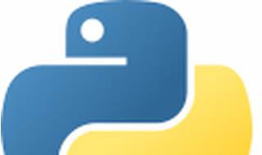

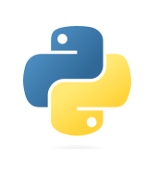

Explore

Certainly! **Python** is an **interpreted, object-oriented, high-level programming language** with dynamic semantics. [It’s widely used for web development, scripting, automation, and data science1](https://www.python.org/doc/essays/blurb/)[2](https://www.geeksforgeeks.org/what-is-python/)[3](https://en.wikipedia.org/wiki/Python_%28programming_language%29). Here are **five free resources** where you can learn Python:

1. **LearnPython.org**: Offers interactive Python tutorials, exercises, and certifications. [You can learn Python for data science here:](https://www.python.org/doc/essays/blurb/) [LearnPython.org4](https://www.learnpython.org/).
2. **Programiz**: Provides step-by-step Python tutorials, examples, and references. [Get started with Python here:](https://www.python.org/doc/essays/blurb/) [Programiz Python Tutorials5](https://www.programiz.com/python-programming).
3. **W3Schools**: Offers a comprehensive Python tutorial with examples, quizzes, and references. [You can also track your progress:](https://www.python.org/doc/essays/blurb/) [W3Schools Python Tutorial6](https://www.w3schools.com/python/).
4. [**Python Official Documentation**: Dive into the official Python tutorial, covering essential concepts and features:](https://www.python.org/doc/essays/blurb/) [Python Tutorial7](https://docs.python.org/3/tutorial/index.html).
5. [**GeeksforGeeks**: Explore Python tutorials, examples, and problem-solving techniques:](https://www.python.org/doc/essays/blurb/) [GeeksforGeeks Python2](https://www.geeksforgeeks.org/what-is-python/).

Happy learning! 🐍🚀